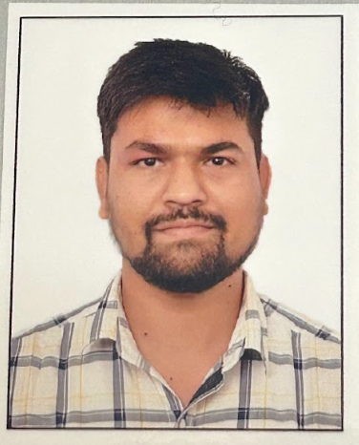 | Name: | Aditya Vishwakarma
 | Role: | Hybris Developer
 | Mobile Number: | +917694880438
 | Email:  Organization: | aditya025vishwakarma@gmail.com  Capgemini India Pvt. Ltd.

SUMMARY
- I have 6+ year's good hands-on experience in SAP commerce data modelling, Flexible search, Cron jobs, Business Process, Workflows, Okta integration, Integration with the Adyen, Impex, Omni Commerce Connect (OCC), Java, Spring, Solr, check-out flow, Backoffice customizations, and Hot folder.
- Experienced in using different software development methodologies like Scrum, Agile, and Waterfall.
- Experience in working on multitude of software projects in terms of complexity and size.
- Experience in writing JUnit test cases and improving Junit test coverage.
- Experience in Writing impex Scripts, .CSV files, Cronjobs, Workflow etc.
- Developed and delivered IT solutions in different domains like E-Commerce, Retail,B2B,B2C.
EDUCATION AND CREDENTIALS
- Bachelors of Engineering in “Electronics and Communication Engineering” - RGTU, Bhopal, India.

TECHNICAL PROFICIENCIES
Technologies | SAP Commerce Cloud (1811, 2011, 2105,2211), JAVA (1.8, 11), SPRING, JSP, JS, REST API, Omni Commerce Connect (OCC), Integration (OKTA, Adyen)
Methodologies & Frameworks | Agile, Waterfall
Platforms | Windows (10,11)
Applications / IDE | Eclipse, IntelliJ IDEA
Tools | GIT, JIRA, Rally, Swagger, Postman, GitHub, Bitbucket

PROFESSIONAL EXPERIENCE
Electrolux B2B Project | Aug 2023– Present
Role: Hybris developer
Project Description
Electrolux based B2B SAP commerce.
In this project implementation for Payment integration, WCMS, Backoffice customizations.
Platforms: SAP Commerce 2211.
Responsibilities:
- Worked on developed Payment integration, WCMS, Backoffice customizations.
- Worked on Data Model, Backoffice validation.
- Worked on Impex for creating Component.
- Worked on JUnit test cases and improving Junit test coverage.
Achievements:
In this project I have implementation validation, WCMS component, Payment integration and learn flow.
------------------------------------------------------------------------------------------------------------------------------------------------------

Hill-Rom B2B Health Project | Nov 2022 – July 2023
Role: Hybris developer
Project Description
Hill-Rom based B2B SAP commerce project.
Funcanality for Okta integration.
Platforms: SAP Commerce 2105.
Responsibilities:
- Worked on developed Okta integration
- Worked create Login page, JSP
- Worked on CMS component

Achievements:
In this project I have implementation OKTA integration.
------------------------------------------------------------------------------------------------------------------------------------------------------
CuraScript SD B2B Project | Dec 2021 – Nov 2022
Role: Hybris developer
Project Description
CuraScript based B2B SAP commerce.
Different functionality in different pages like Cart, Checkout, Order Pad.
Platforms: SAP Commerce 2105.
Responsibilities:
- Worked on developed user stories in different module, fixed bugs.
- Worked in frontend as well.
- Unit testing.

Achievements:
In this project I have implementation with frontend developer and learn FED worked as well.

BH DS Store Spartacus and DS Druck | May 2021 – Nov 2021
Role: Hybris developer.
Project Description
DS store Spartacus project focuses on migration the existing Ds store from hybris version to the updated Hybris Commerce version (Spartacus).
Platforms: SAP Commerce 2011.
Responsibilities:
- Worked on developed Rest API, and create new fields in different Pages like – cart, checkout and confirmation page.
- Worked on developed user stories in different module, fixed bugs.
Achievements:
In this project I have implementation technology Omni Commerce Connect (OCC) and Spartacus.

NextGen-Ecommerce | Oct 2019 – March 2021
Role: Hybris developer.
Project Description
This project involves the development of a fully functional e-commerce application using SAP Commerce suit. This web site facilitates B2C customers to experience end to end e-commerce features like search, cart, and order.
Platforms: SAP Commerce 1811.
Responsibilities:
- Worked on data modelling and showing the attributes in different pages. (PDP, SRP and cart page.)
- Developing Cron jobs to generate reports.
- Worked on sending process-based emails.
- Worked on Impexes, flexible search queries, controllers, facades, services, DAOs and JSP.
Achievements:
In this project I have implementation technology SAP Commence in live project and delivered

Work Experience

Capgemini Technology Services India Limited - April 2021 – Present

C-NET INFOTECH PVT. Limited - Jan 2018 – March 2021

Training & Certifications

- SAP Certified Development Professional - SAP Commerce Cloud 1905 Developer.
- SAP Certified Product Support Specialist SAP Commerce.

